St Oliver Plunkett’s
Primary School
Forkhill



Internet Safety and
Acceptable Usage Policy

Ratified: December 2021

Review Date: January 2025

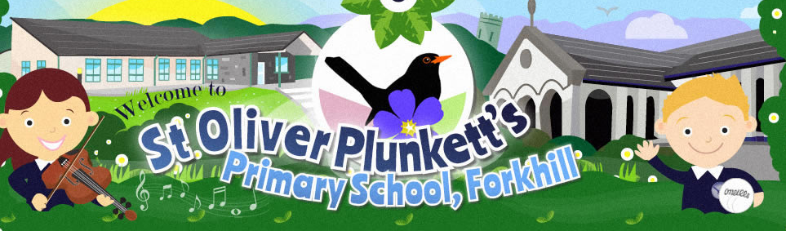

Dear Parents,

As part of your child’s curriculum and the development of ICT skills, St. Oliver Plunkett’s P.S. is providing supervised access to the Internet. We believe that the use of the Internet is worthwhile and is an essential skill for children as they grow up in the modern world. Please read the attached Rules for Responsible Internet Use, and discuss them with your child.

Our school Internet Provider operates a filtering system that restricts access to inappropriate materials.
In St. Oliver Plunkett’s we take the following steps to ensure an acceptable use of the Internet.

- Use of filtered Internet Service Provider.
- Children's use of the Internet is a supervised activity.
- Websites used by the children will be viewed by staff prior to use and also regular checks will be made on the computer's Internet browser, bookmarks, cache, or history.
- Children will be informed about and understand the attached Rules for Responsible Internet Use.

Whilst every endeavour is made to ensure that suitable restrictions are placed on the ability of children to access inappropriate materials, the school cannot be held responsible for the nature or content of materials accessed through the Internet. The school will not be liable for any damages arising from your child’s use of the Internet facilities.

If you have any concerns regarding your child’s use of the Internet in school, then you are most welcome to contact the school for further information.

Yours sincerely,
Mr Woods

Steps We Take to Protect Children in School

Use of a Filtered Service
Access to the Internet is provided through a filtered service. All access is provided through the NINE Connect service which is designed to filter out unsuitable material.

Supervision
No filtering service is 100% effective, therefore all children’s use of the Internet is supervised by an adult.

Planned Activities
Use of the Internet is a planned activity. Aimless surfing is not allowed. Children are taught to use the Internet in response to a need e.g. a question which has arisen from work in class.

Websites are previewed by teachers and revisited to ensure that they are suitable for children’s curriculum needs and ability levels.

Search engines are used selectively e.g. Swiggle for an advert free web and image only search. Teachers will choose the search engine and topic and discuss sensible search words which have been tried out beforehand.

Restrictions on E-mail
Children are not given individual web-based e-mail addresses. In some instances, children may have access to a group e-mail address to communicate with other children as part of a particular project or task. Messages sent and received in this way are supervised by the teacher.

Internet Safety Rules
Children are taught to be Internet Wise. Children are made aware of Internet Safety Rules and are encouraged to discuss how to cope if they come across inappropriate material.

Use of Securus
Securus is an e-monitoring application that monitors pupils on C2K managed devices using key stroke monitoring and application monitoring technologies. Issues and concerns detected by Securus include:
Cyber Bullying,
Online grooming, child abuse, exploitation,
Depression, self harm and suicide,
Racial, homophobic and religious harassment,
Use of drugs or weapons,
Attempts to use a proxy bypass to access restricted sites,
Radicalisation and extremism.

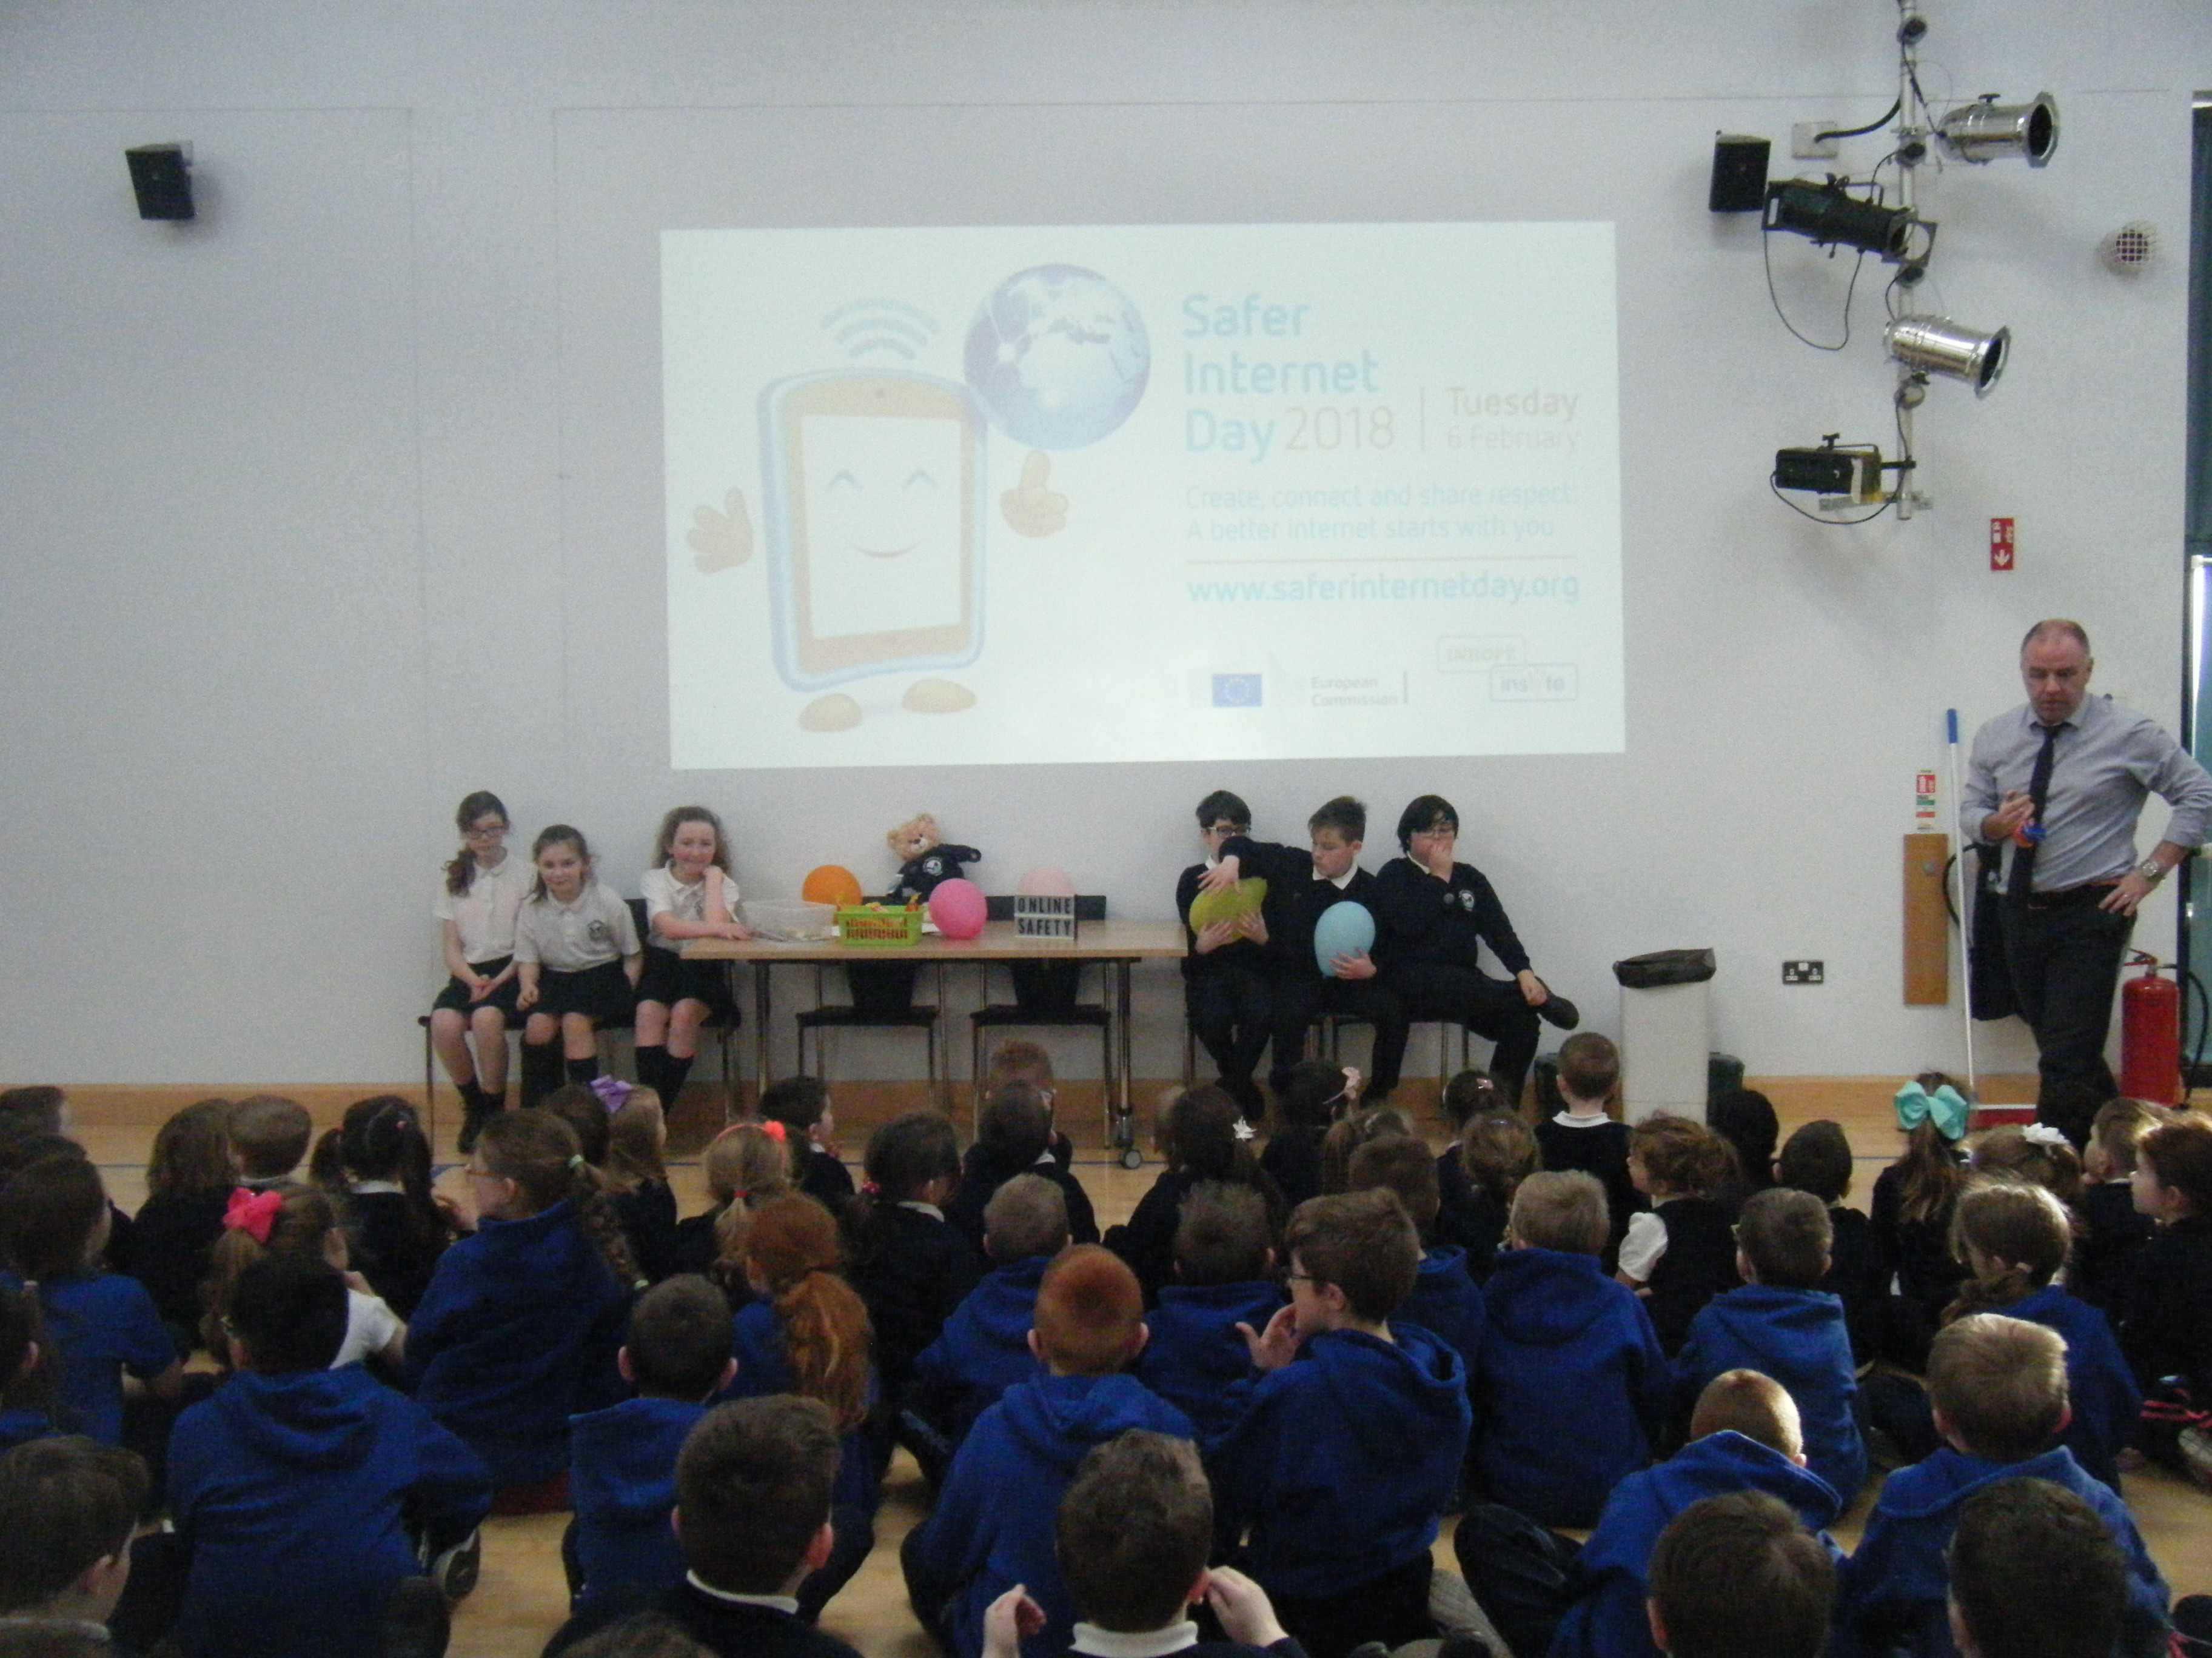
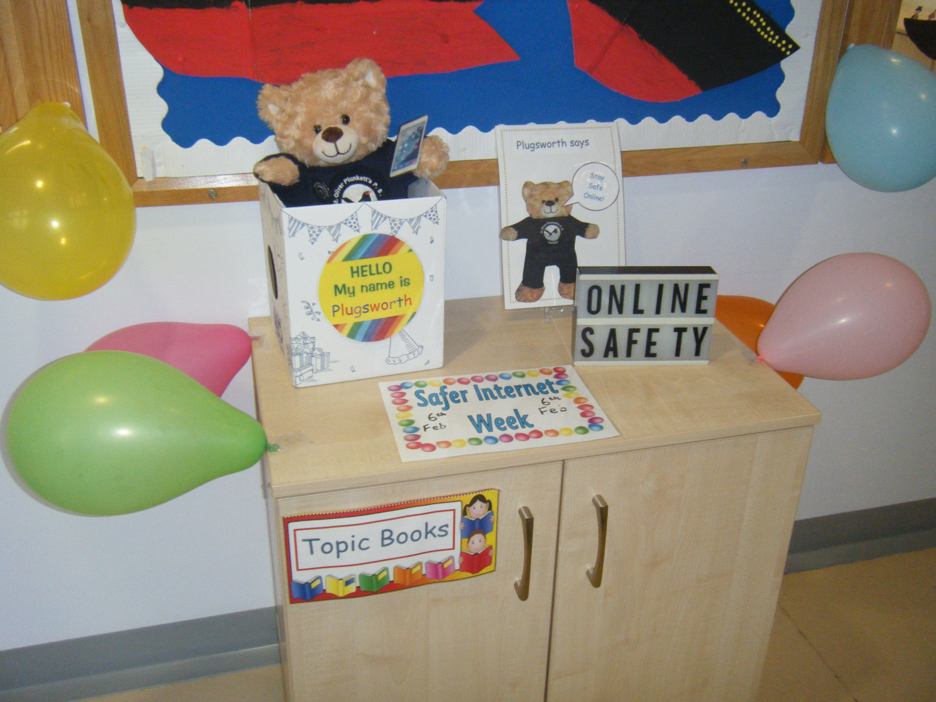

Mobile Phones
Children are not permitted to bring mobile phones to school. In the event of children being in possession of a mobile phone, it will be removed by an adult in school immediately. It will then be sent to the office for safe keeping and it can only be returned on collection by a parent from the school office. During school hours children are forbidden to play computer games or access social networking sites.

Internet Safety Awareness
In St. Oliver Plunkett’s P.S. we believe that, alongside having a written

safety policy and Code of Practice Agreement, it is essential to educate all users in the safe and effective use of the Internet and other forms of digital communication. We see education in appropriate, effective and safe use as an essential element of the school curriculum. This education is as important for staff and parents as it is for children. Other ways of promoting good practice is through the use of our Digital Leaders group, whole school assemblies, our Internet Safety mascot, Internet Safety books/eBooks, displays around school and parent’s information evenings.

Digital and Video Images of Children
Parental permission is sought at the start of each school year to cover the use of photographs of children on the school website, in the local press and for displays etc within school and written permission must be obtained from parent/carer.

School Website
Our school website promotes and provides up to date information about the school, as well as giving children an opportunity to showcase their work and other aspects of school life. In order to minimise risks of any images of children on the school website being used inappropriately the following steps are taken:

o Group photos are used where possible, with general labels/captions;
o First names are only every associated with photographs;
o The website does not include home addresses, telephone numbers, personal e-mails or any other personal information about children or staff.

NB. Pupils’ photographs may be published subject to the strict safeguards listed above. If you have any concerns / objections, please contact the school.

Storage of images
Digital and video images of children are taken with school equipment. Images are stored in the staff folder area on the school network, accessible only to teaching staff. Photographs of children are archived when they leave the school.

Social Software
Chat-rooms, blogs and other social networking sites are blocked by the C2K filters so children do not have access to them in the school environment. However, we regard the education of children on the safe and responsible use of social software as vitally important and this is addressed through our Internet Safety Education for children.

Points for Parents to Consider

It is important to promote Internet Safety in the home and to monitor Internet use.

- Keep the computer in a communal area of the home.
- Ask children how the computer works.
- Monitor on-line time and be aware of excessive hours spent on the Internet.
- Take an interest in what children are doing. Discuss with the children what they are seeing and using on the Internet.
- Advise children to take care and to use the Internet in a sensible and responsible manner. Know the SMART tips.
- Discuss the fact that there are websites which are unsuitable.
- Discuss how children should respond to unsuitable materials or requests.
- Remind children never to give out personal information on the Internet.
- Remind children that people on line may not be who they say they are.
- Be vigilant. Ensure that children do not arrange to meet someone they meet on line.
- Be aware that children may be using the Internet in places other than in their own home or at school.
- Mobile Phones. Be aware of the safety issues regarding mobile phones. Increasingly these may have Internet access. Encourage children to talk about how they use mobile phones. Remind children not to give mobile numbers to strangers and people they do not know very well. Talk about responsible use of text messaging.

All reasonable and appropriate steps have been taken to protect pupils. The school recognises that despite employing safety procedures, in some circumstances, the Internet may give children access to undesirable information or images.

Children are regularly reminded that should they encounter inappropriate material on line they must immediately
- Close down the laptop lid or press the home button
- Inform an adult

Should a child or teacher encounter unsuitable material through using the NINE Connect service, this will be reported to C2k via the C2k helpdesk number.

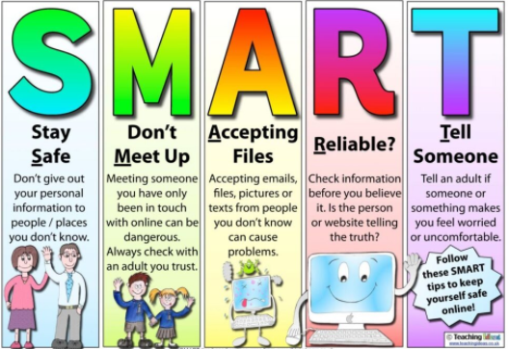

Sanctions

Incidents of technology misuse which arise will be dealt with in accordance with the school’s discipline policy. Incidents will be dealt with by the Principal/ICT Co-ordinator and may result in a temporary or permanent ban on Internet use. Incidents involving child protection issues will be dealt with in accordance with school child protection procedures.

INTERNET SAFETY RULES

- On the network, I will only use my own login username and password.

- I will not look at, change or delete other people’s work/files.

- I will ask permission before entering any website, unless my teacher has already approved that site.

- I will only send e-mail which my teacher has approved. I will make sure that the messages I send are polite and sensible.

- When sending an e-mail, I will not give my name, address or phone number or arrange to meet anyone.

- I understand that I am not allowed to enter Internet Chat Rooms while using school computers.

- If I see anything I am unhappy with or I receive messages I do not like, I will tell a teacher immediately.

I understand that if I deliberately break these rules I could be stopped from using the Internet.

Points for Children to Consider

Follow These SMART TIPS

S
Secret - Always keep your name, address, mobile phone number and password private – it’s like giving out the keys to your home!

M
Meeting someone you have contacted in cyberspace can be extremely dangerous. Only do so with your parent’s/carer’s permission, and only when they can be present.
A
Accepting e-mails or opening files from people you don’t really know or trust can get you into trouble – they may contain viruses or nasty messages.
R
Remember someone on-line may be lying and not be who he or she say they are.

T
Tell your parent or carer if someone or something makes you feel uncomfortable or worried.

SMART Tips from: – Helping your parents be cool about the Internet, produced by: Northern Area Child Protection Committees

